# CS 255 Business Requirements Document

Student: Cory Remick

Professor: Kim-Marie Foss

Date: 7/30/2022

## System Components and Design

### Purpose

*What is the purpose of this project? Who is the client and what do they want their system to be able to* DriverPass wants to improve driver training by offering both online and in-person instruction and tests to students.

### System Background

* The client asked us to build a system where students can study DMV material, take practice tests, and schedule on-the-road training.
* DriverPass wants to increase the number of driving students that pass the test on their first try. They currently estimate only 35% pass on their first try.
* The system should be available on the web.
* Backend system reports should be available for download and use offline.

### Objectives and Goals

* Students can register online.
* Secretaries can register students over the phone.
* Students should be able to select and pay for packaged deals that include a certain number of hours of instruction.
* Students should be able to reserve a car and driver for in-person instruction on a specified day and for a system configured number of hours (client says 2 hours at a time).
* Students should be able to read material and take practice exams on the web.
* Admins need to be able to perform account management to change passwords and create/disable accounts.
* Admins need to know data change history. For example, who made a reservation, who canceled it, and who last modified a record.
* Drivers need to know what student they are scheduled with, when, which car, and for how long (currently 2 hours).
* Drivers should be able to update the scheduled lesson to add comments after the lesson.
* System should alert admins to changes in DMV rules, policies, or sample questions.

## Requirements

### Nonfunctional Requirements

* Cloud Solution
  + Available anytime/anywhere
* Backup
  + Regional Replication for disaster recovery
* Security
  + Firewalls
  + TLS Encryption Certificates and Ciphers
* Web Server
* Load Balancer
* Middle Layer Server
* Database Layer Server

#### Performance Requirements

* Web-based application
* Page interactive response <= 0.1 seconds (Nielsen, 1993)
* Page navigation <= 1.0 seconds (Nielsen, 1993)
* Reports and Long Processes <= 10 seconds (Nielsen, 1993)
  + Processing indicator (spinner) required
* Processes > 10 seconds
  + Progress indicator (progress bar) required

#### Platform Constraints

*To decrease operating costs, I recommend the LAMP (Linux, Apache, MySQL) platform.*

* Server: Unix OS
* Web Server: Apache
* Server DB: MySQL configured for High Availability (commercial costs involved)
* Middle Tier: Java Spring Framework

#### Accuracy and Precision

* Case-insensitive
* Users distinguished by role
* Problems logged immediately to a log server
* Triggers on log server will notify admin of problems

#### Adaptability

* Users can be added, removed, changed by the Administrator user in real time.
* Platform updates will be handled by the IT administrator.
  + Web servers will be load balanced across 2+ servers.
  + Half the servers will be removed from balancer and updated, then returned to service.
  + The other half will be removed and updated and returned to service.
  + Middle tier will be balanced across 2+ servers.
  + Same update procedure as web servers.
  + Database server
  + Update standby server
  + Promote standby server to master
  + Update previous master database server

#### Security

* Forms Authentication (username & password)
* Password complexity policy
* Authentication must use TLS 1.2+
  + Forward Secrecy Ciphers Only
  + Encryption Ciphers verified by SSL Labs ([SSL Server Test (Powered by Qualys SSL Labs)](https://www.ssllabs.com/ssltest/))
* More than 5 failed login attempts should lock account for 15 minutes
  + Log failure
* Users can click Forgot Password
  + System sends email to address on file
  + The email contains a temporary link (15 minutes till expires)
  + User clicks link
    - Check if link is expired
    - User enters email address
    - New password
    - New password confirmation
    - Password is verified against complexity rules
    - Password changed
* Roles
  + Admin
  + Driving Instructor
  + Teacher
  + Student
  + Registrar
  + Scheduler

### Functional Requirements

* The system shall validate user credentials when logging in.
* The system shall record change history to records.
* The system shall let students schedule driving instruction for themselves.
  + Read/Create/Update/Cancel
* The system shall let Scheduler schedule driving instruction for any student.
  + Read/Create/Update/Cancel
* The system shall let Scheduler assign cars and drivers to schedule.
  + Read/Create/Update/Delete
* The system shall let Registrar manage students.
  + Read/Create/Update/Disable (not delete)
* The system shall let the Administrator manage user accounts.
  + Read/Create/Update/Disable/Assign Role
* The system shall let the Administrator manage cars.
  + Read/Create/Update/Delete
* The system shall let the Administrator manage training packages.
  + Read/Create/Update/Deactivate
* The system shall let the Student purchase training packages.
* The system shall notify the administrator of DMV rules, policy, and sample question changes.
* The system reports shall be compatible with Excel

### User Interface

* Online Test Progress (students, admin)
  + Test Name
  + Time Taken
  + Score
  + Status (Not taken, in progress, failed, passed)
* User Information (admin, user's own record)
  + First name
  + Last name
  + Address
  + City
  + State
  + Zip
  + Phone
  + Email
  + Role
  + Credit Card (for students)
  + Photo
* Driver Notes (drivers)
* Lesson Schedule Management (admin, scheduler, drivers)
  + Date
  + Start Hour
  + End Hour
  + Driver Notes
  + Special Needs
* Contact Us (public)
* Vehicle Management (admin)
* Driver Management (admin)
* Student Management (admin, registrar)
* Sales Package Management (admin)

### Assumptions

* The customer devices support the TLS protocol version and configured ciphers.
* The solution will be compatible with the customer's browser.
* The client will be able to budget and afford the cloud hosting provider's solution costs.
* The server technologies are adequate for the solution.
* The consulting staff can work with the technologies.
* The client's IT staff are capable of operating and maintaining the solution.
* Database can handle requirements, especially scale and availability.
* Platforms are free of known defects (bugs and security holes) and routinely patched.

### Limitations

* Consulting staff are available for project
* Customer has funds for project

### Gantt Chart

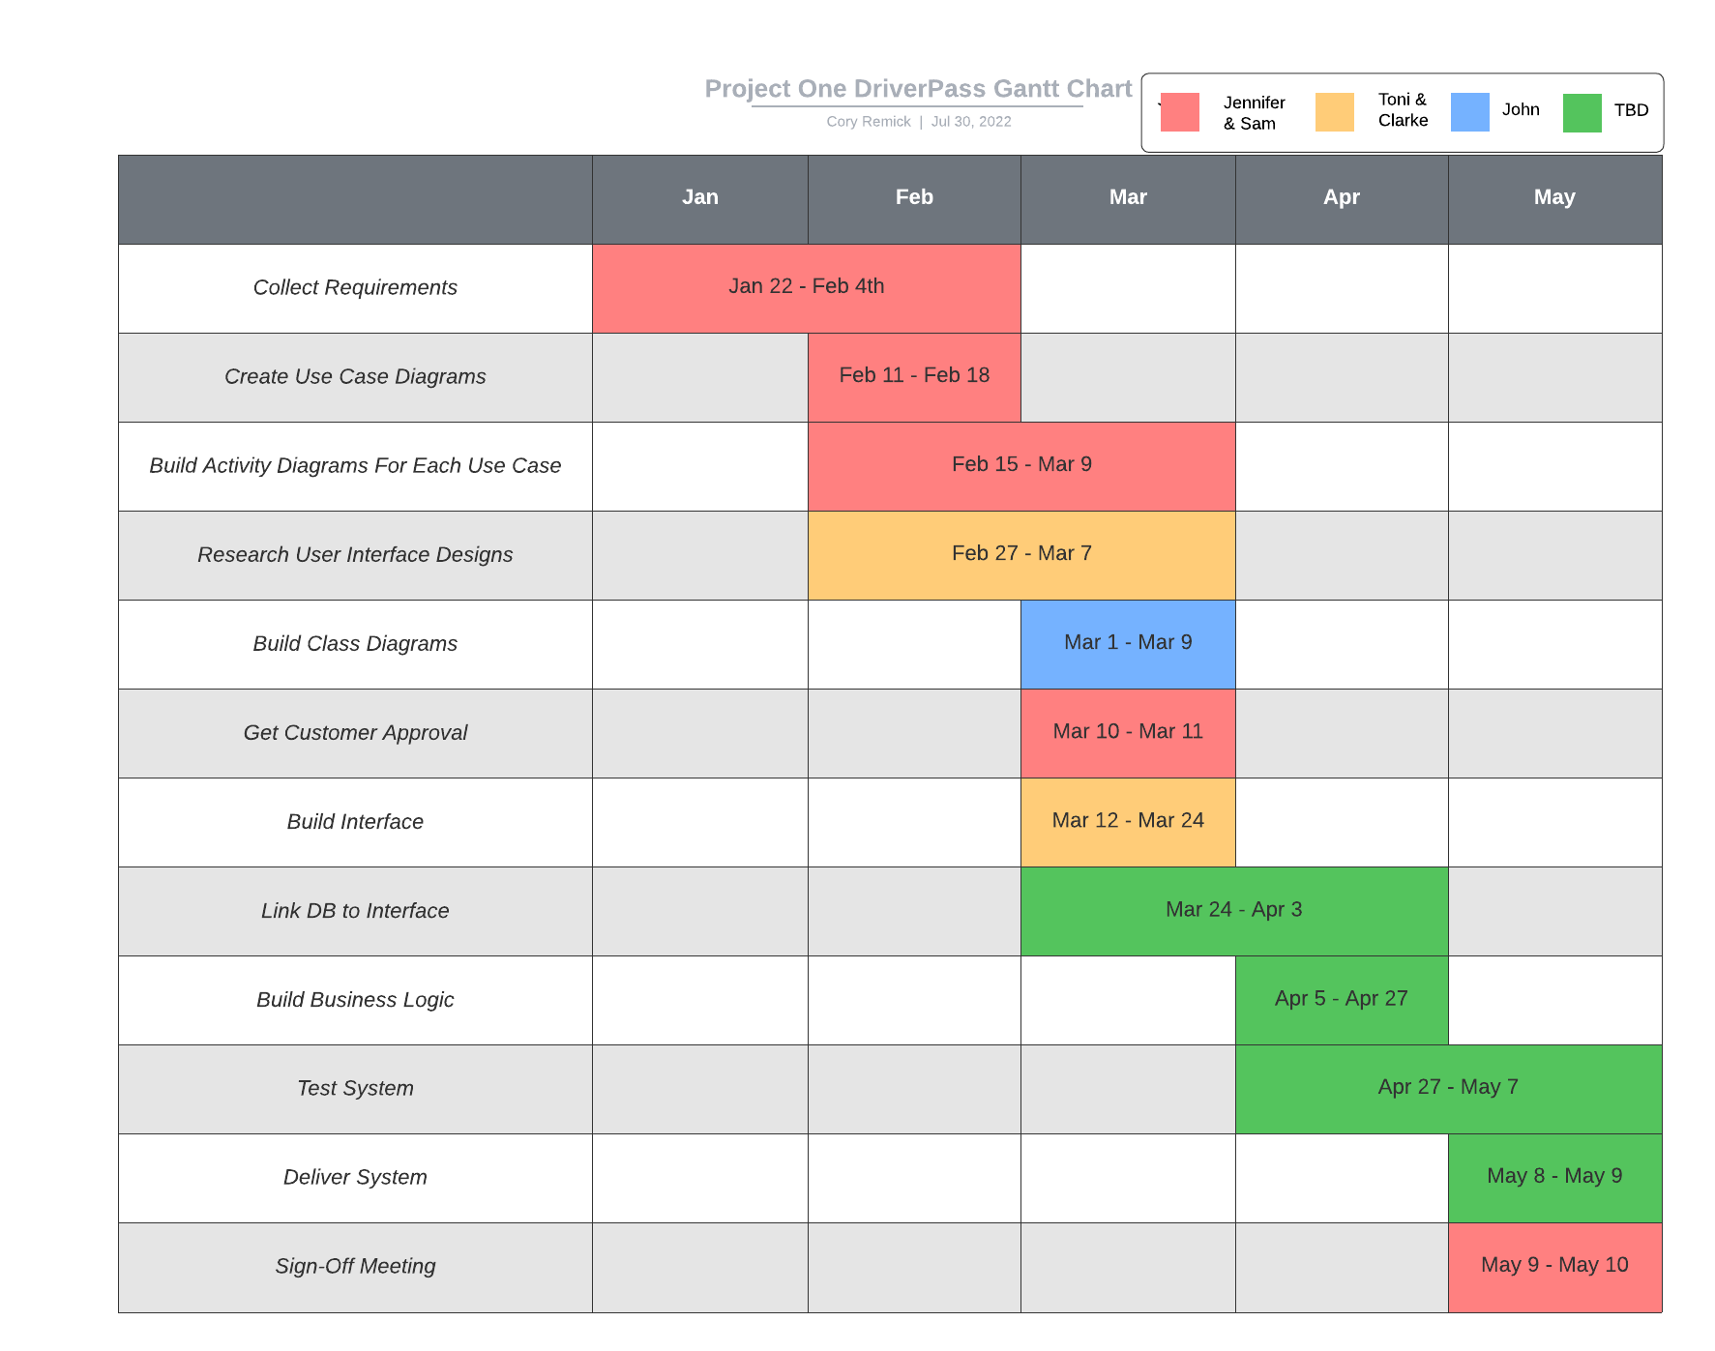

# References

Nielsen, J. (1993). *Usability Engineering* (Paperback Edition ed.). San Francisco: Morgan Kaufmann.